**Project Design Phase-II**

**Data Flow Diagram & User Stories**

|  |  |
| --- | --- |
| Date | 11 October 2022 |
| Team ID | PNT2022TMID14574 |
| Project Name | AI BASED DISCOURSE FOR BANKING INDUSTRY |
| Maximum Marks | 4 Marks |

**Data Flow Diagrams:**

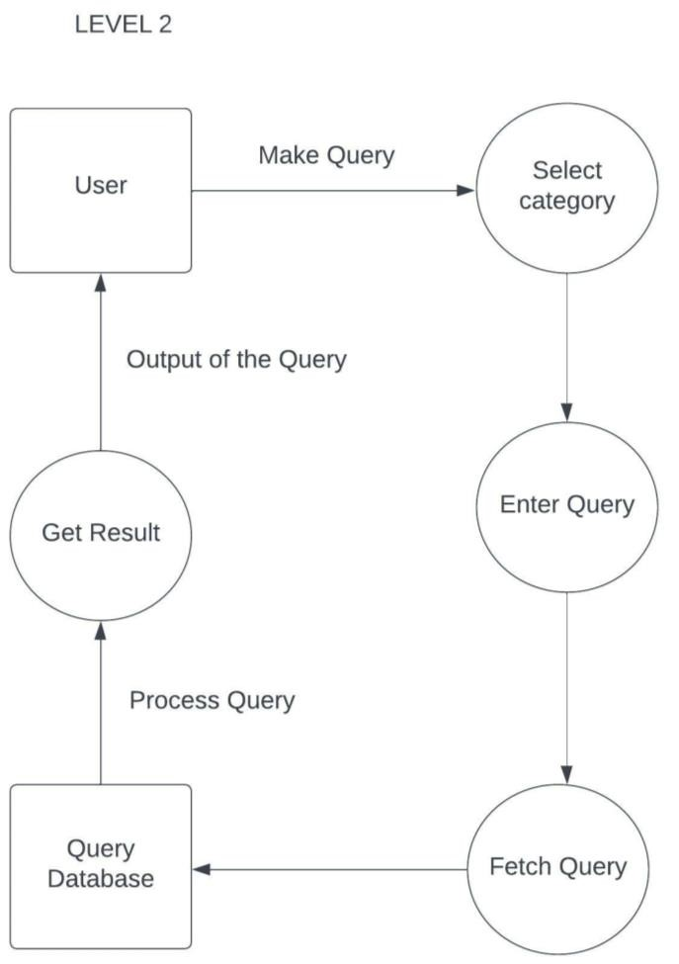

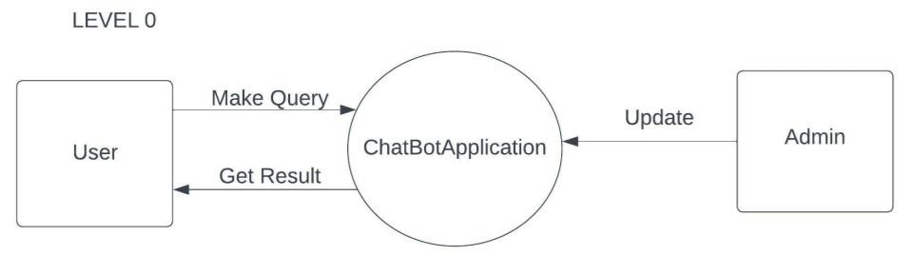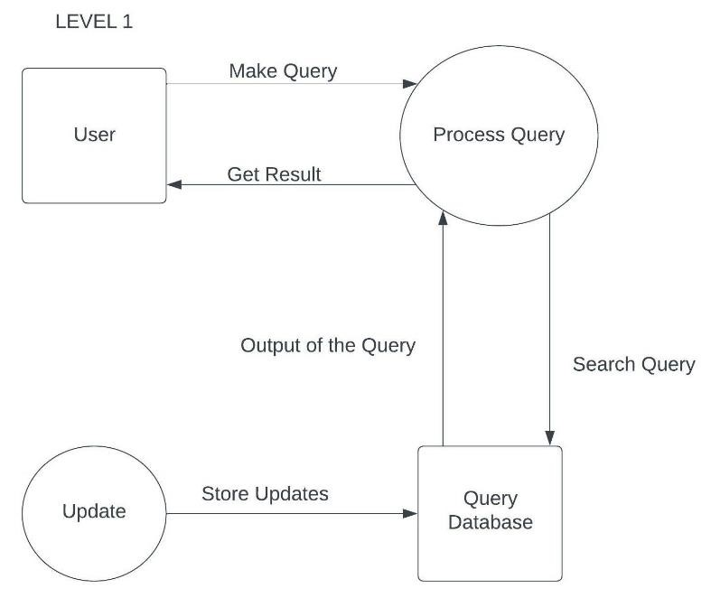

|  |  |  |  |  |  |  |
| --- | --- | --- | --- | --- | --- | --- |
| **User Type** | **Functional**  **Requirement (Epic)** | **User Story**  **Number** | **User Story / Task** | **Acceptance criteria** | **Priority** | **Release** |
| Customer (Mobile or Web user) | Savings Account Related Actions | USN-1 | As a user, in the Savings Account option, I can select Types of Savings Account to get details regarding documents required for creating that savings account. | I can clear my queries regarding types of savings  account | High | Sprint-1 |
|  |  | USN-2 | As a user, I can check the Interest Rates of Savings Account | I can clear my queries regarding interest rates of savings account | High | Sprint-1 |
|  |  | USN-3 | As a user, I can check the Minimum Balance of Savings Account | I can clear my queries regarding minimum balance of savings account | Medium | Sprint-2 |
|  | Current Account Related Actions | USN-4 | As a user, I can choose the Type of Company to know the information on documents to be submitted for creating current account | I can clear my queries regarding types of companies | High | Sprint-1 |
|  |  | USN-5 | As a user, I want to get details on procedure to close my Current Account | I can clear my queries regarding current account closure | High | Sprint-2 |
|  | Loan Account Related Actions | USN-6 | As a user, I can choose the Type of Loans to know the information on choosing an essential loan scheme | I can clear my queries regarding types of loan account | High | Sprint-1 |
|  |  | USN-7 | As a user, I can check the Loan Amounts that can be offered for corresponding Loan Accounts chosen | I can clear my queries regarding loan amounts of loan account | High | Sprint-2 |
|  |  | USN-8 | As a user, I can check the Status of Loan for my Loan Accounts | I can clear my queries regarding loan status of  loan account | Low | Sprint-2 |
|  | General Queries Related Actions | USN-9 | As a user, I want to get the procedure details for Currency Conversion facility of my bank account | I can clear my queries regarding currency  conversion facilities of bank account | Low | Sprint-1 |
|  |  | USN-10 | As a user, I want to check my CIBIL score for my loan application and to ensure whether my loan application is approved by the bank. | I can clear my queries regarding CIBIL score of loan application | Medium | Sprint 3 |
|  |  | USN-11 | As a user, I want to get the procedure details for maintaining Storage Locker facility of my bank account | I can clear my queries regarding storage locker facilities of bank account | High | Sprint-3 |
| **User Type** | **Functional**  **Requirement (Epic)** | **User Story**  **Number** | **User Story / Task** | **Acceptance criteria** | **Priority** | **Release** |
|  | Net Banking  Related Actions | USN-12 | As a user, I want to get the procedure details for changing the Net Banking password of my bank account | I can clear my queries regarding change of net banking password | Medium | Sprint-2 |
|  |  | USN-13 | As a user, I can select types of fund transfers to get details regarding different services available in net banking | I can clear my queries regarding types of fund transfers in net banking | High | Sprint-3 |
|  |  | USN-14 | As a user, I want to get the procedure details for adding beneficiaries to my net banking account. | I can clear my queries regarding adding beneficiaries in net banking | Low | Sprint-3 |
| Administrator |  | USN-15 | As an admin, I can change responses to queries and modify them as and when needed. | I can modify responses of the chatbot | Medium | Sprint-1 |
|  |  | USN-16 | As an admin, I can added more options to queries and add new options as new features get added. | I can add more options and queries into the chatbot | Medium | Sprint-1 |